St Mary’s CE Primary Wellbeing Hub Newsletter
Term 4 ~ Signposting

www.facebook.com/PortisheadCommunityFridge/
Community fridges are open to all and encourage our community to share and use food that would otherwise go to waste.
Did you know that they are open 3 days a week? Make sure you take a bag.

Mondays @Avon Way Co-Op 11am Wednesdays @Avon Way Co-Op 3.30pm Saturdays @Somerset Hall 10am

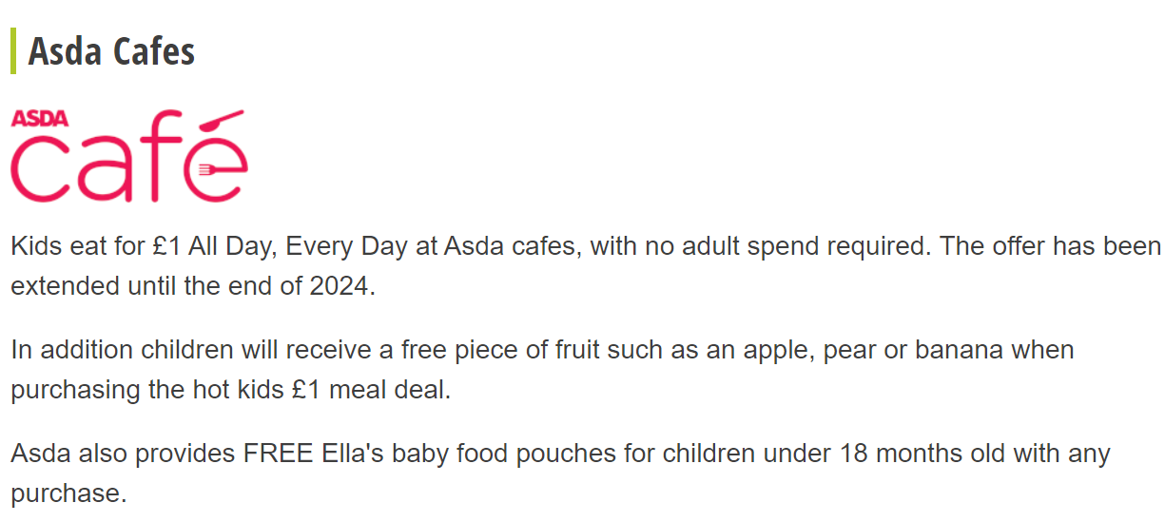
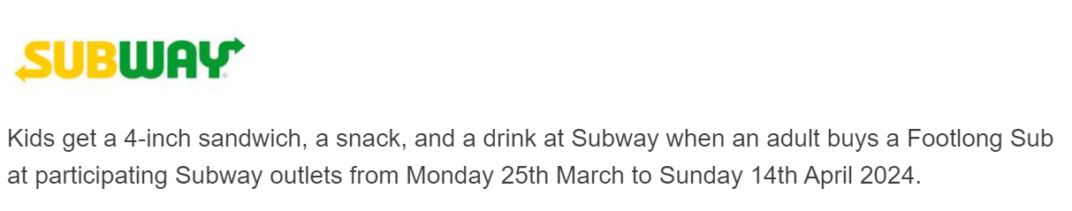

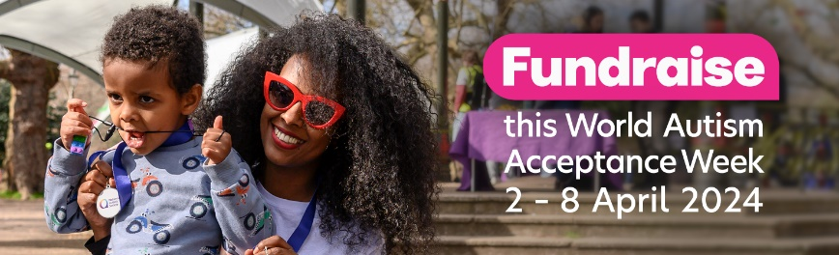
Term 4 ~ SEND

Autistic people face discrimination and barriers across all sectors of society – in the health and social care systems, in education, in employment, and everywhere in between. It is crucial that autistic people, and their families and carers, can access tailored information, guidance and support to overcome those barriers, along with opportunities to explore their interests, develop skills and build friendships for fulfilled lives.

World Autism Acceptance Week is back from 2nd April to 8th April 2024! The theme for 2024 is colour, and they have a new virtual challenge, the Spectrum Colour Challenge; a new in-person event, the Spectrum Colour Walks; and lots of ideas to get your fundraising off to a colourful start. If you wish to take part.
https://www.autism.org.uk/ support.
700,000 autistic people in the UK. Every penny raised helps to deliver their ambitious plans to transform our society into one that truly works for autistic people. Why not support by trying out the recipe.

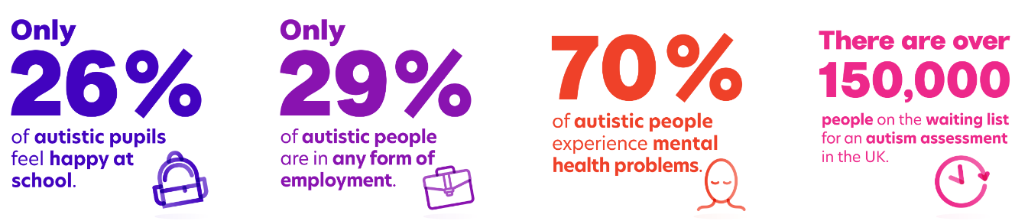

Please feel free to contact Mrs Sheppard or
Mrs Blundell via the school office if you have any Special Educational Need/Disability (SEND) question.
We are here to help.


Term 4 ~ Online Safety
Staying Safe Online
There are lots of ways to help keep your child safe online. Below are the CBeebies and CBBC links to keeping safe online along with games and film clips to help your family talk about online safety together.
https://www.bbc.co.uk/cbeebies/grownups/article-internet-use-and-safety
https://www.bbc.com/ownit/curations/staying-safe
If you haven't already used this, the Internet Matters guide can help you set parental controls on all devices around your home
https://www.internetmatters.org/parental-controls/

What does PEGI rate the game Fortnite?
Due to its frequent scenes of mild violence, Fortnite was rated 12+ by PEGI. Even though PEGI have amended some of the games as PG, please note the content of these games and frequency in which children seem to be playing.

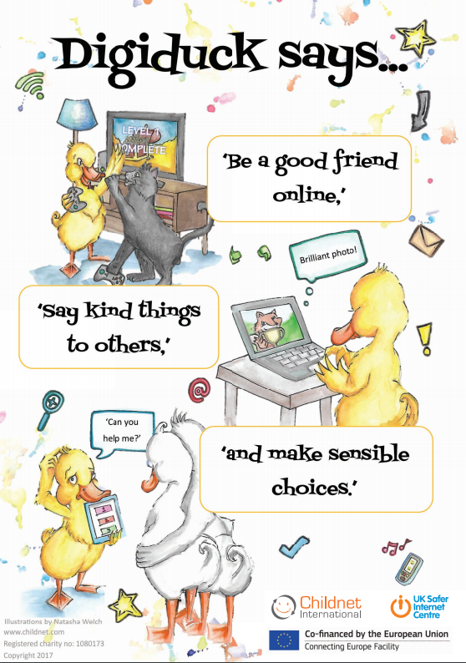
Term 4 ~ Mindfulness
Mrs Blundell’s Hot Chocolate Breathing
During Term 3, we have been thinking about healthy minds.
Learning mindful breathing can help pupils to develop awareness of their feelings and bodies, help to focus their minds and calm their bodies. This simple life skill is a great tool for children’s overall wellbeing as they learn to manage the daily challenges in their lives.

Whether you like chocolate or not – give it a go!
https://www.youtube.com/watch?v=9o85KNSUXh8
https://www.youtube.com/watch?v=2drtTVc2sVs





